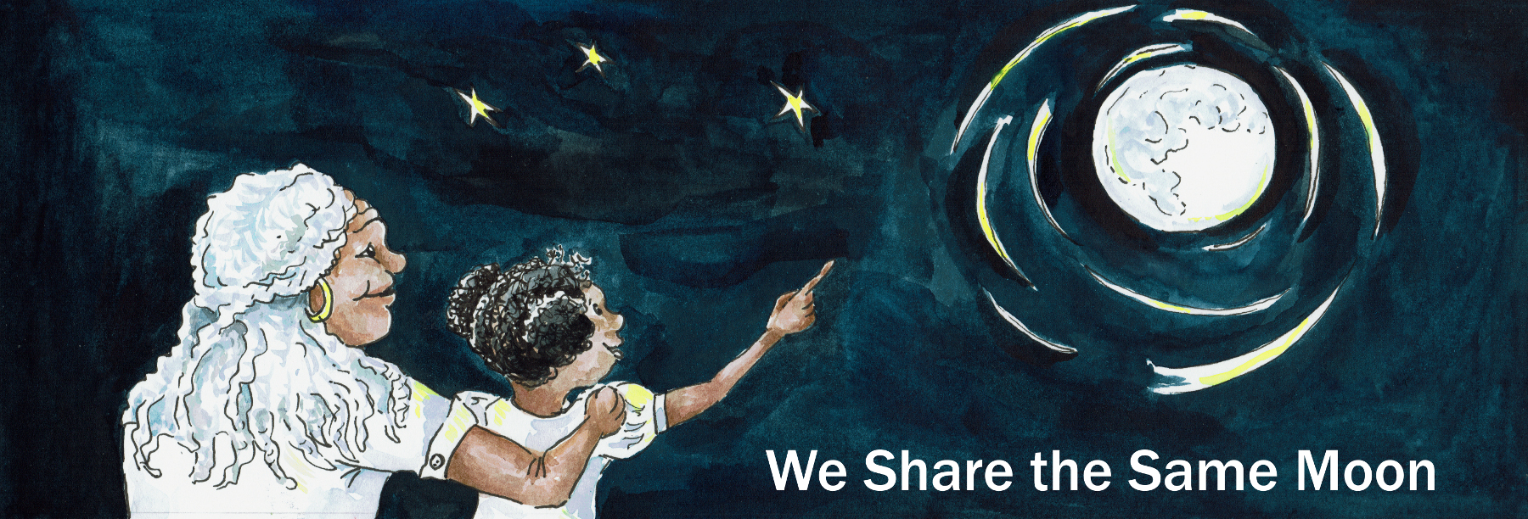
Suggested Age Range: 7- 8 years; 8 - 9 years: 9- 10 years; 10- 11 years;
Suggested UK Year Group: Year Three, Year Five
UK Curriculum: Key Stage Two (Lower); Key Stage Two (Upper)
UK Curriculum Links: Rocks; Earth and Space;
Science Subject: The Moon
Science Question: Why Does the Moon have Craters?
Suggested Science Activity: Cosmic Craters, Moon Globes
Children with SEND: Use with children to boost science vocabulary
EAL children: Intermediate Level
Country of Origin: Vietnam
Source: Sky-legends of Vietnam by Lynette Dyer Vuong

Long ago in Vietnam, at the edge of the rainforest, there was a house.
And in that house lived a young man.
He had very few possessions, a knife, a cooking pot and a dog, that he had found lost as a puppy wandering alone through the forest and limping from a damaged leg.
The young man and his dog were inseparable.
They went everywhere and did everything together.
Every day, they would walk into the forest, looking for scraps of wood.
The man would gather the pieces of wood into a bundle and then they would take them to market to sell to the traders who worked there.
And with the money they made from the wood, they bought food for their supper to eat.
If they sold a lot of wood, they ate plenty.
If they only sold a little, then they only had a little to eat.
But, whatever they had, they shared equally. The dog was the young man’s only friend.

One day, as they walked into the shade of the forest, they heard something!
The call of a baby animal in distress.
The young man, without thinking, ran towards the sound,
only to discover it was a baby tiger with a bleeding wound on his stomach.
The young man stopped short.

What should he do?
If he rescued the baby tiger, then one day, it would grow up to be a danger to him.
You cannot tame a tiger.
But, he couldn’t bear to leave the little animal suffering all alone. What to do?
At that moment, the decision was taken out of his hands.
There was an ominous growl and a huge roar.The mother tiger was coming!
The young man, grabbed his dog and started climbing up a tree as fast as he could.
He prayed that the tiger would not see or smell him.
The man and his dog hid between the branches, shivering with fright.
Then, he young man looked down. And he saw, a very strange thing.
The mother tiger walked up to her baby, licked his wound once and then turned towards a Baobab tree that was growing in the far corner of the clearing.
She bit off some of the leaves and whilst chewing them slowly, she walked back to her cub. And then, she bent and placed the chewed leaves upon the wound.
And to the young man’s astonishment, it began to heal!
In front of his amazed eyes, he saw, the wound begin to close, the blood begin to clot and the skin to heal. Until, there was no sign of a wound left on the cub’s body.!
The tiger cub sprang up and chased after its mother.
And in a moment, they were gone.

The man thought he must be dreaming!
Then, he remembered his dog’s leg and the old wound that still caused him pain.
He climbed down the tree and carefully placed the dog on the forest floor, walked over to the Baobab tree and broke off some of the leaves.
He tore them into tiny pieces and mixed them with some of his saliva, just like the tiger.
He spread the paste over the dog’s old injured leg and waited.
And in front of his eyes, the scar began to disappear, the leg straightened and the dog leapt up and ran round the clearing barking with excitement!

The young man was convinced. He had discovered a healing tree!
And from that day, every day when he went into the forest to collect wood,
he would take just a few of those leaves and place them in a bag.
And, when anyone in his village was sick, he would use the leaves to cure them.
He never asked for any money, but the villagers paid him instead with gifts of food, clothes and blankets. And the life of the young man and his dog began to change.

One day, news came to the village. The man who owned the village, his daughter, his only child, was seriously, dangerously ill.
No doctor had been able to cure her. It was said that she would soon die.
The young man decided to try and save her with the help of the healing tree.
He knew that as a poor young man, the rich man would view him with suspicion and so he dressed in his newest of clothes. The dog went with him - of course!
At the door, it took a while to persuade the rich man to let him in, but the father was so desperate, he was willing to try anyone and anything!

The young man, went to the girl’s room, where she lay in bed, pale as moonlight.
He opened his bag, took out some of the leaves,
broke them into pieces and and mixed them with a little cold tea.
He placed the paste upon her eyes, her forehead, her arms and her legs.
And to the astonishment of her father, her skin colour began to change, from pale as death to golden. Her skin cooled and her eyes opened and she smiled, at both at the her father, and at the young man. And the young man’s heart beat fast when she did so.
In time, as you might expect, the two were married and the young man and his dog came to live in the rich man’s house. And their lives was transformed.

But every day, he insisted on going back to the forest and his old home, to heal the people of his village. And in time - this became his downfall.
For his young wife grew jealous of the time he spent away from her.
And so one day, she followed him.
And she saw, with jealous eyes, the love he gave to a tree.
“He loves that tree more than me!” she thought, furiously.
And that night, whilst he was asleep, she came up with a plan to get rid of the tree, her rival for her husband’s love..
It was the night of the full Moon, and so whilst the whole house was asleep, she crept out, her house and into the forest. In her hand she clutched an axe.
And she went up to the healing tree and swung the axe!
And as the blade bit into the tree’s trunk - the tree screamed!
The young man heard the scream and woke up! "My tree, my tree is dying” he cried..
He ran, the dog following, out of his room, his home and into the forest.
He found his wife, striking the tree over and over with the axe..
The tree was almost dead, leaning to one’s side with a huge gash in its trunk and the roots beginning to give way.
“No!” cried the young man “No, no, no! What are you doing?”
“This tree is evil” said his wife. “This tree has taken you from me. You love this tree more than me!”
“No, no no, no!” said the young man. “You do not understand, this tree saved you!”
He wrapped his arms around his tree and cried and cried and cried.
And then, the tree broke loose from its roots and began to fall.
“No!” cried the young man. “No! Don’t leave me!”

And then the tree did one last miracle.
It began to rise, with the young man still wrapped around it, up and up into the air.
And up and up it rose, until it landed upon the Moon.
And, they say in Vietnam, that if you look carefully,
you can still see the young man on the Moon, sitting beneath with his tree.

But …
Scientists say that that the shapes that we see on the Moon, are in fact, dark patches of rock that hit the Moon long ago.
But what do YOU think is true?

Copyright Cassandra Wye May 2019

